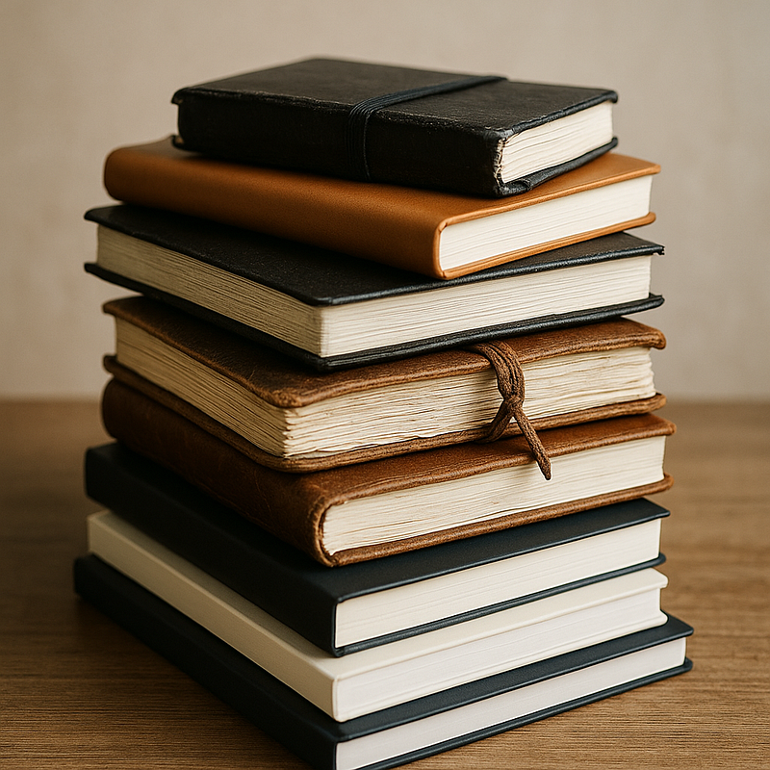

Unmarked
On notebooks, thresholds, and the tyranny of the pristine

When last I counted, there were between five and ten notebooks on my shelves at home with the first ten pages filled and then nothing after. Moleskine special editions. Some really nice Japanese Midoris. A few non-brand names that seemed, at the time, like they might become the exception. Each one pulses with ideas that started off with velocity and then dissipated at a predictable rate: about ten pages in.
Clustered near them are six more, pristine, new, untouched. Some still in their protective wrappers, stacked with the kind of precision that makes a desk look organized from a distance. The one I’m currently jotting in sat unused for about two years before I finally opened it. I turned past the first blank page and hesitated. Then I wrote, anyway.
It’s the blankness that’s hardest to face. The untouched ones accumulate. Sometimes I take one out, just to feel the weight of it, to flip it open and see if I’m ready to ruin the first page. Most of the time, I put it back, unwritten. The blankness asks for something worthy. The blankness, for now, remains.

The Wager of the First Mark
The clean notebook promises a kind of potential untouched by history: a fresh start, an unspoiled space where something definitive or important might finally appear. The first mark becomes a wager: this time, the words will be worthy, the project will hold together, the intentions will match the artifact. There’s a superstition built into it, the sense that the initial line will set the terms for everything that follows. If I get it right, maybe I can sustain coherence, clarity, control. If I get it wrong, the error will ripple through every page, unrecoverable.
This veneration feels inherited, half from school (where the blank sheet was always the test, the opportunity, the performance) and half from a culture that prizes the new, the untouched, the flawless object. There’s a fear of error braided into it, a reluctance to admit the inevitability of revision, the normalcy of mess. A clean notebook is a fantasy about who I might become if I just began in the right way. It is easier, often, not to begin.

Disorder as Initiation
Disorder is inevitable. Even the most carefully maintained notebook will gather its share of stray marks: ink that bleeds through paper too thin for ambition, lines that wander off their margin like thoughts escaping form, notes to self written in a different mood. The covers fray, the spine softens, a page tears loose at the edge. False starts proliferate. What seemed like a promising thread on page three is struck out by page five, replaced by another impulse, equally provisional.
To want the object to remain unmarked is to want immunity from this entropy, a promise that intention can be separated from execution, that the artifact can remain unsullied by the evidence of imperfect thinking. Maybe it’s about control, the fantasy that order can be imposed on the flux of a mind by keeping the material world clean. Or maybe it’s a refusal to see mistakes made visible, a way of avoiding the reckoning with what’s provisional, false, or unfinished. The unmarked notebook stands for the possibility of never having to confront the record of my failed starts.

An Archive of Refusal
Derrida, in Archive Fever, reminds us that every archive is shaped as much by exclusion as by inclusion, by what is left out, by what remains unsaid, by the drives that select, suppress, defer. The archive is not only a storehouse but also a structure of desire and anxiety, haunted by what it cannot contain. The partially filled notebook becomes an archive of its own impossibility: a visible trace of the wish to record and the simultaneous compulsion to preserve the blankness, the option, the potential for a better start. It is the persistence of the threshold, rather than the document, that comes to define the collection.
My stack of partially filled notebooks is less an archive of writing than of refusal: evidence of hesitance, perfectionism, the deferred desire to begin. Each abandoned volume preserves a record not of what was written, but of what was withheld. A gap. A hesitation. An empty page that stays empty. These are artifacts of decision, not of inspiration. In this sense, the archive is not a collection of texts but of interruptions and retreats, a stratigraphy of intention’s collapse.

Breaking the Recursive Loop
What if sullying the notebook is the rite of entry, not the failure. The first blot, the crossing out, the misaligned heading: not a flaw, but initiation. Disorder as the only way out. Intention yielding to action, risk taken, artifact begun. Yet the logic circles back. The blankness exerts its pressure, demands significance, dares me to justify intrusion. I hesitate, revise in my head, postpone the moment. The blankness wins. I dirty the page, or I don’t. The notebook waits.

The Imagined Reader
Who is the blankness really for? Is it a private standard, a silent negotiation with myself, or does it secretly perform for an imagined audience, some future reader, or a future self, leafing back through the record to assess the quality of the opening lines? The care with which I preserve the pristine page starts to feel less like respect for the object and more like anticipation of judgment.
Perhaps the real anxiety is not about ruining the notebook, but about leaving evidence for someone who might later come searching for origins, meaning, or failure. Maybe I’m not preserving the blankness at all, but rehearsing the encounter with a reader who is always just out of frame, waiting to measure what I wrote against what could have been written. The blankness remains because the imagined reader never arrives, never releases me from the obligation to begin perfectly. I wait in the threshold, arranging and rearranging the conditions for entry, while the notebooks accumulate their particular silence: not empty, but withheld.

This handwritten essay lives on pages 5–7 in a Castelli notebook.

